CRYPTOGRAPHY LAB EXPERIMENTS
Experiment – 1:
Code:
#include <stdio.h>
#include <string.h>
#include <ctype.h>
int main() {
char text[100];
int k, i;

printf("Enter the text: ");
fgets(text, sizeof(text), stdin);
printf("Enter the key (1-25): ");
scanf("%d", &k);

if (k < 1 || k > 25) {
printf("Invalid key! Key must be between 1 and 25.\n");
return 1;
}

for (i = 0; text[i] != '\0'; i++) {
if (isupper(text[i])) {
text[i] = ((text[i] - 'A' + k) % 26) + 'A';
}
else if (islower(text[i])) {
text[i] = ((text[i] - 'a' + k) % 26) + 'a';
}
}
printf("Encrypted text: %s", text);

return 0;
}

Output:
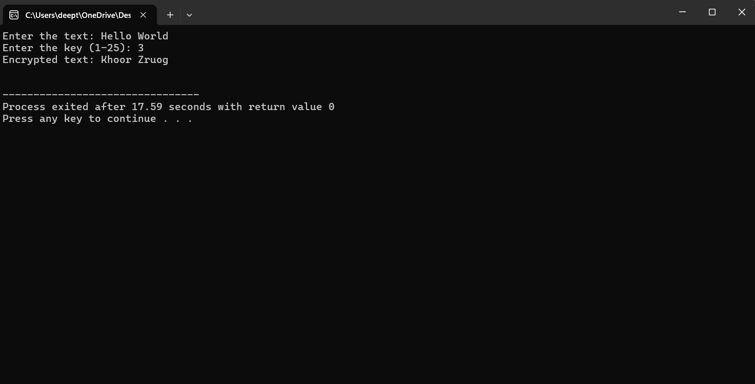

Experiment – 2
Code:
#include <stdio.h>
#include <ctype.h>

int main() {
char text[100];
char key[] = "QWERTYUIOPASDFGHJKLZXCVBNM";
int i;

printf("Enter the plaintext: ");
fgets(text, sizeof(text), stdin);

for (i = 0; text[i] != '\0'; i++) {
if (isupper(text[i]))
text[i] = key[text[i] - 'A'];
else if (islower(text[i]))
text[i] = tolower(key[text[i] - 'a']);
}

printf("Encrypted text: %s", text);

return 0;
}

Output:
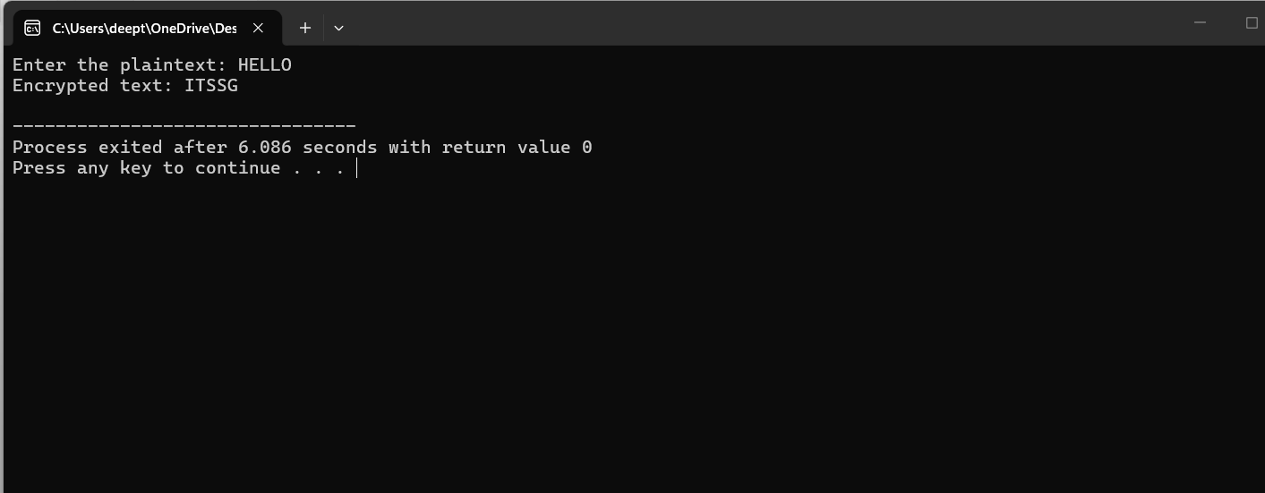

Experiment – 3
Code:
#include <stdio.h>
#include <string.h>
#include <ctype.h>

char matrix[5][5] = {
{'M','O','N','A','R'},
{'C','H','Y','B','D'},
{'E','F','G','I','K'},
{'L','P','Q','S','T'},
{'U','V','W','X','Z'}
};

void findPosition(char ch, int *row, int *col) {
if (ch == 'J')
ch = 'I';

for (int i = 0; i < 5; i++) {
for (int j = 0; j < 5; j++) {
if (matrix[i][j] == ch) {
*row = i;
*col = j;
return;
}
}
}
}

int main() {
char text[100], pair1, pair2;
int i, r1, c1, r2, c2;

printf("Enter Plaintext (uppercase): ");
scanf("%s", text);

printf("Ciphertext: ");

for (i = 0; i < strlen(text); i += 2) {
pair1 = toupper(text[i]);
pair2 = (i + 1 < strlen(text)) ? toupper(text[i + 1]) : 'X';

findPosition(pair1, &r1, &c1);
findPosition(pair2, &r2, &c2);

if (r1 == r2) {
printf("%c%c", matrix[r1][(c1 + 1) % 5],
matrix[r2][(c2 + 1) % 5]);
}
else if (c1 == c2) {
printf("%c%c", matrix[(r1 + 1) % 5][c1],
matrix[(r2 + 1) % 5][c2]);
}
else {
printf("%c%c", matrix[r1][c2],
matrix[r2][c1]);
}
}

return 0;
}

Output:
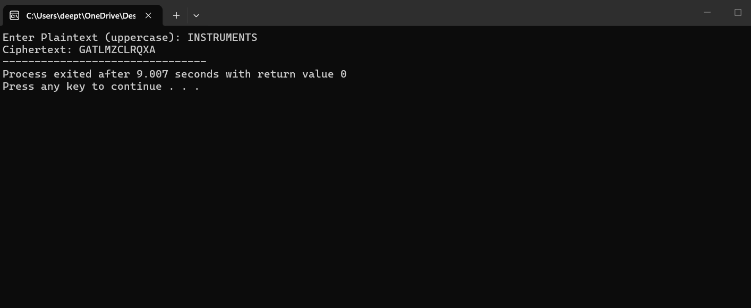

Experiment – 4
Code:
#include <stdio.h>
#include <string.h>
#include <ctype.h>

int main()
{
char text[100], key[100];
int i, j = 0;

printf("Enter Plaintext (UPPERCASE): ");
scanf("%s", text);

printf("Enter Key (UPPERCASE): ");
scanf("%s", key);

printf("Ciphertext: ");

for(i = 0; i < strlen(text); i++)
{
char ch = text[i];

if(ch >= 'A' && ch <= 'Z')
{
printf("%c", ((ch - 'A') + (key[j] - 'A')) % 26 + 'A');
j++;

if(key[j] == '\0')
j = 0;
}
else
{
printf("%c", ch);
}
}

return 0;
}

Output:
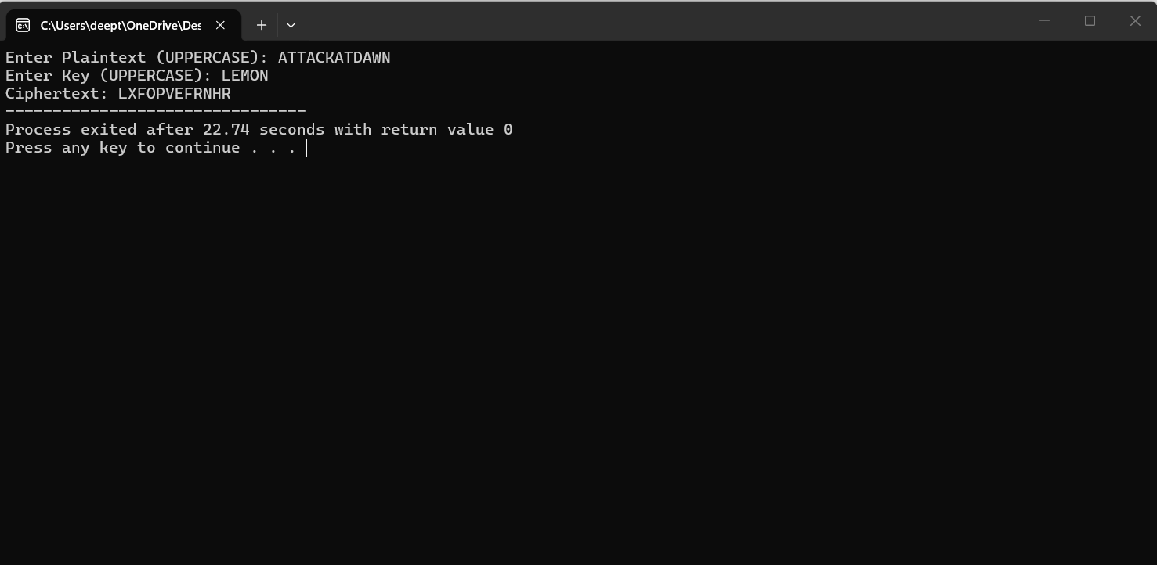

Experiment – 5
Code:
#include <stdio.h>
#include <string.h>

int gcd(int a, int b)
{
while(b != 0)
{
int t = b;
b = a % b;
a = t;
}
return a;
}

int main()
{
char text[100];
int a, b, i;

printf("Enter Plaintext (UPPERCASE): ");
scanf("%s", text);

printf("Enter value of a: ");
scanf("%d", &a);

printf("Enter value of b: ");
scanf("%d", &b);

if(gcd(a,26) != 1)
{
printf("Invalid value of a. It must be coprime with 26.");
return 0;
}

printf("Ciphertext: ");

for(i = 0; text[i] != '\0'; i++)
{
if(text[i] >= 'A' && text[i] <= 'Z')
printf("%c", ((a * (text[i]-'A') + b) % 26) + 'A');
else
printf("%c", text[i]);
}

return 0;
}

Output:
